Dear Parent/Carer

Thank you for choosing to order kit for your child from the HCC Sports Academy range

Please complete the form below so we can process your order. Once your order has been placed, the amount
will be added to your Parent Pay account and will need to be paid before your order can be completed. If you do not
have a Parent Pay account, a bar coded letter will be produced by the Finance department. Please elect this option
in the details table.

Kit Options

The kit images table below are the current HCC Sports Academy options available to order and are acceptable to wear in PE lessons, travelling to fixtures and in Sports Academy sessions. You can see what the garments look like within the table and can also check what sizes are available by clicking on the link below. Simply add the quick reference number from the kit options table below into the search bar.

Please note that the prices on the website do not include embroidery and postage & packaging. https://www.prodirectsoccer.com/

Once you have decided on your kit option, please check the size on the size guide below and then complete the form and send to finance@honitoncollege.devon.sch.uk. You will need to fill the subject field with - HCC SPORTS ACADEMY ORDER FORM

Size Guide - https://www.nike.com/gb/en_gb/c/size-fit-guide/mens-tops-sizing-chart.

Details
Student’s name:
Parent/Carers name:
ParentPay/Bar coded letter. Select appropriate payment method
Delivery address: | Honiton Community College, School Lane, Honiton, Devon. EX14 1QT
Contact telephone number:
Contact Email address:

Order
Item Description | Quick Ref | Size | Colour | Quantity | Price
Total |  |  |  |  | £
Kit Options – Childrens Sizes
Item Description | Image | Colour | Quick Reference Number | Price (including crest embroidery and post and packaging)
Childs T-Shirt | 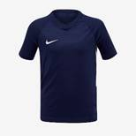 | Midnight navy/white | 176691 | £14
Childs T-Shirt | 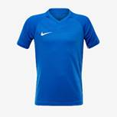 | Royal blue/white | 176689 | £14
Childs long sleeved training top | 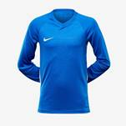 | Royal blue/white | 176701 | £15
Childs long sleeved training top | 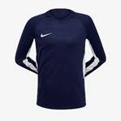 | Midnight navy/white | 176703 | £15
Training Pants | 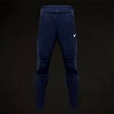 | Obsidian blue | 176804 | £19

Kit Options – Adult Sizes

Item Description | Image | Colour | Quick Reference Number | Price (including crest embroidery and post and packaging)
Men’s T-shirt | 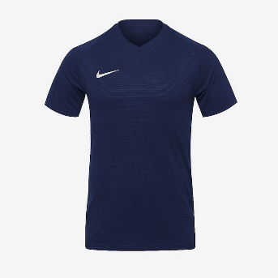 | Midnight navy / royal blue | 176546 | £17
Men’s T-shirt | 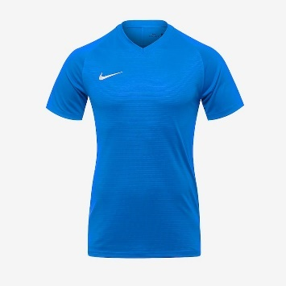 | Royal blue | 176544 | £17
Men’s LS jersey | 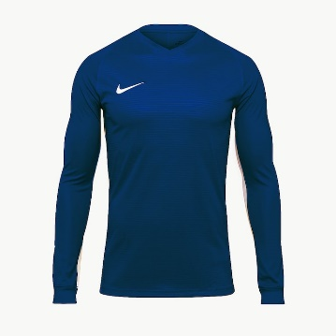 | Midnight Navy/White | 176558 | £19
Men’s LS jersey | 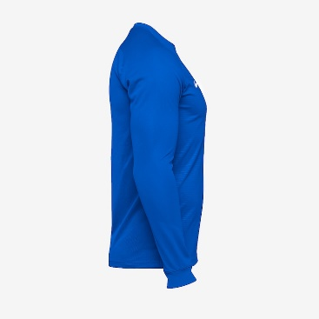 | Royal Blue/White | 176566 | £19
Ladies T-shirt | 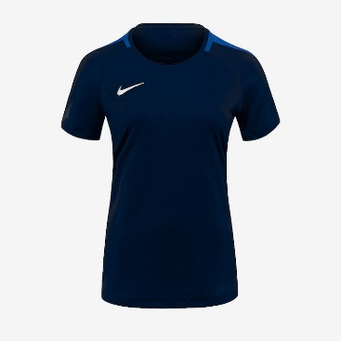 | Obsidian/royal blue | 199335 | £17
Ladies T-shirt | 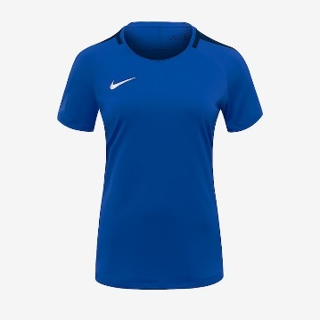 | Royal/obsidian blue | 199336 | £17

Additional Information/Notes

Delivery details
PRO:DIRECT SOCCER will send out all orders directly to Honiton Community College every half term. Once you have
placed your order, it will be added to the next bulk delivery and Mr Skelding will inform students when the order is
ready to be collected.

If you have any queries directly for PRO DIRECT, please use the contact details below.

TEAMSPORT SALES TEAM

TEL +44(0)371 663 4442

PRO:DIRECT SPORT LTD
Torre House, Shaldon Road,
Newton Abbot, Devon TQ12 4PQ

